EXP3:

CODE:  
<!DOCTYPE html>

<html lang="en">

<head>

<meta charset="UTF-8">

<title>Register</title>

<style>

.head{

background-color:yellow;

color:black;

padding:10px;

font-size:45px;

}

body{

margin:10px;

}

.nav{

background-color:orange;

padding:10px;

text-align:right;

}

.nav a{

color:black;

margin-left:10px;

text-decoration:none;

}

.nav a:hover{

background-color:black;

color:wheat;

}

.foot{

background-color:black;

color:white;

padding:10px;

text-align:center;

}

.mid{

text-align:center;

height:400px;

}

#banner {

padding: 1px;

width: 800px;

height: 80px;

}

#bg

{

height:500px;

width:1080px;

}

</style>

</head>

<body>

<h1></h1>

<div>

<div>

<center><img id="banner" src="pp.png"></center>

</div>

<div class="head">

BE CSE 2020-21

</div>

<div class="nav">

<a href="index.htm">HOME</a>

<a href="studentlist.html">STUDENT LIST</a>

<a href="timetable2.html">TIMETABLE</a>

<a href="subjectlist.html">SUBJECT LIST</a>

<a href="syllabus.html">SYLLABUS</a>

</div>

<p2><marquee> NKOCET approved by AICTE New Delhi, opened its gate for technology Education from 2008-09.It is recognized by Gov. Of Maharashtra & affiliated to Dr. Babasaheb Ambedkar Technological University, Lonere (DBATU).</marquee></p2>

<div>

<center><img id="bg"src="adf.jpg"></center>

</div>

</html>

OUTPUT:

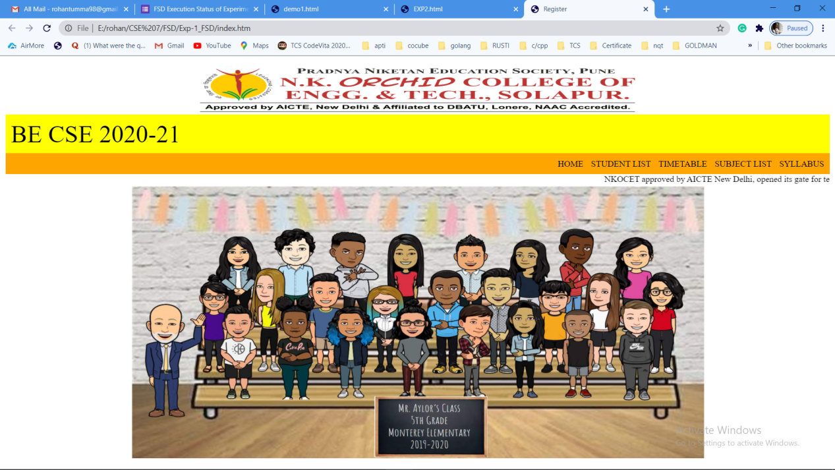

CODE:  
<!DOCTYPE html>

<html>

<head>

<style>

table, td, th {

border: 1px solid black;

padding: 5px

}

table {

border-collapse: collapse;

width: 100%;

}

th {

height: 50px;

}

.head{

background-color:yellow;

color:black;

padding:10px;

font-size:45px;

}

body{

margin:10px;

}

.nav{

background-color:orange;

padding:10px;

text-align:right;

}

.nav a{

color:black;

margin-left:10px;

text-decoration:none;

}

.nav a:hover{

background-color:black;

color:wheat;

}

.foot{

background-color:black;

color:white;

padding:10px;

text-align:center;

}

.mid{

text-align:center;

height:400px;

}

#banner {

padding: 1px;

width: 800px;

height: 80px;

}

#bg

{

height:500px;

width:1080px;

}

</style>

</style>

</head>

<body>

<div>

<center><img id ="banner"src="pp.png"></center>

</div>

<div class="head">

BE CSE 2020-21

</div>

<div class="nav">

<a href="index.htm">HOME</a>

<a href="studentlist.html">STUDENT LIST</a>

<a href="timetable2.html">TIMETABLE</a>

<a href="subjectlist.html">SUBJECT LIST</a>

<a href="syllabus.html">SYLLABUS</a>

</div>

<p2><marquee> NKOCET approved by AICTE New Delhi, opened its gate for technology Education from 2008-09.It is recognized by Gov. Of Maharashtra & affiliated to Dr. Babasaheb Ambedkar Technological University, Lonere (DBATU).</marquee></p2>

</div>

<h2 align="center">Student List</h2>

<table style="width:40%" align="center">

<tr>

<th>Roll No.</th>

<th>Name of Student</th>

</tr>

<tr>

<td align="center">1</td>

<td align="center">Rohan Tumma</td>

</tr>

<tr>

<td align="center">2</td>

<td align="center">Tejas Bhosale</td>

</tr>

<tr>

<td align="center">3</td>

<td align="center">Sankalp Koreshetti</td>

</tr>

<tr>

<td align="center">4</td>

<td align="center">Nitin ghodke</td>

</tr>

<tr>

<td align="center">5</td>

<td align="center">Prasad </td>

</tr>

<tr>

<td align="center">6</td>

<td align="center">tejas</td>

</tr>

<tr>

<td align="center">7</td>

<td align="center">rohan</td>

</tr>

<tr>

<td align="center">8</td>

<td align="center">shubham</td>

</tr>

<tr>

<td align="center">9</td>

<td align="center">rakesh</td>

</tr>

<tr>

<td align="center">10</td>

<td align="center">nithin</td>

</tr>

</table>

</body>

</html>

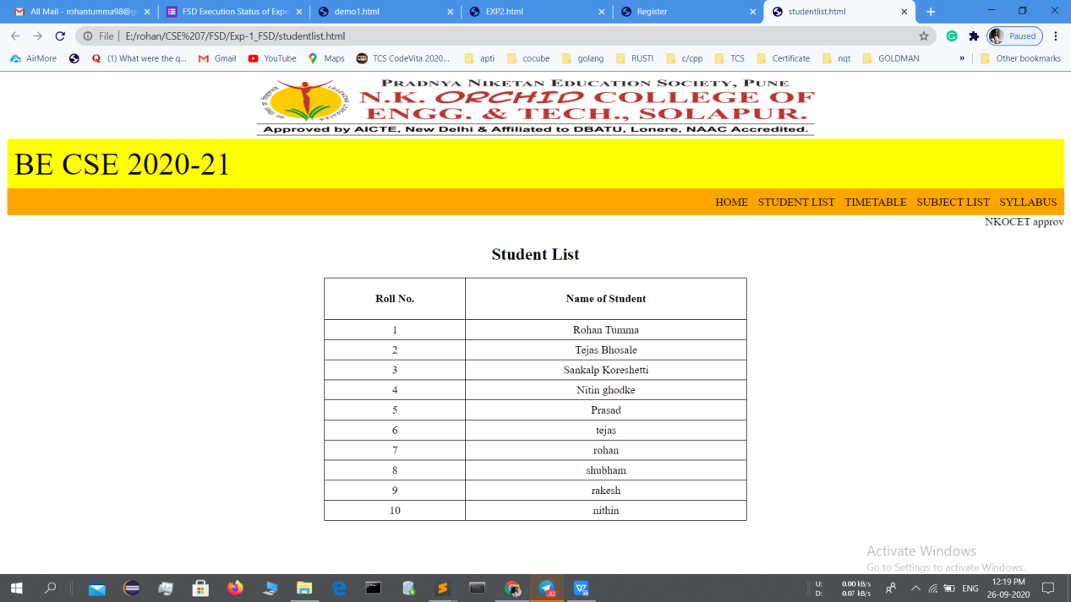

Code:

<html>

<head>

<title>syllabus</title>

<style>

.head{

background-color:blue;

color:black;

padding:10px;

font-size:45px;

}

body{

margin:10px;

}

.nav{

background-color:orange;

padding:10px;

text-align:right;

}

.nav a{

color:black;

margin-left:10px;

text-decoration:none;

}

.nav a:hover{

background-color:black;

color:wheat;

}

.foot{

background-color:black;

color:white;

padding:10px;

text-align:center;

}

.mid{

text-align:center;

height:400px;

}

#banner {

padding: 1px;

width: 800px;

height: 80px;

}

#bg

{

height:500px;

width:1080px;

}

</style>

</head>

<body>

<div>

<center><img img id ="banner"src="pp.png"></center>

</div>

<div class="head">

BE CSE 2020-21

</div>

<div class="nav">

<a href="index.htm">HOME</a>

<a href="studentlist.html">STUDENT LIST</a>

<a href="timetable2.html">TIMETABLE</a>

<a href="subjectlist.html">SUBJECT LIST</a>

<a href="syllabus.html">SYLLABUS</a>

</div>

<p2><marquee> NKOCET approved by AICTE New Delhi, opened its gate for technology Education from 2008-09.It is recognized by Gov. Of Maharashtra & affiliated to Dr. Babasaheb Ambedkar Technological University, Lonere (DBATU).</marquee></p2>

<div>

<h1><center>\*\*\*SYLLABUS\*\*\* </h1></center>

<h2><center>BTCOL706 System Administration</h2></center><br>

1. Installations of various Linux flavors (Optionally using Virtualbox): Centos (with

LVM, without LVM), Ubuntu (with LVM, without LVM), Debian (with LVM, without

LVM).<br>

2. SSH Server (CentOS and Ubuntu): enable/disable root login.<br>

3. Telnet server (CentOS and Ubuntu).<br>

4. FTP Server (CentOS and Ubuntu).<br>

5. Using command upload/download files from FTP Server.<br>

6. Samba Server (CentOS and Ubuntu).<br>

7. Http Server (CentOS and Ubuntu).<br>

8. Configuration of Proxy Server.<br><br><br>

<b>Reference Books:</b><br>

1. Tom Adelstein, Bill Lubanovic, Linux System Administration: Solve Real-life Linux

Problems Quickly, O'Reilly Media.<br>

2. Æleen Frisch, Essential System Administration, Third Edition, O'Reilly Media.<br>

3. Terry Collings, Kurt Wall, Red Hat Linux Networking and System Administration, 3rd

Edition, Wiley Publication.<br><br>

<h2><center>BTCOL705 Full Stack Development (LAMP / MEAN)</center></h2><br>

<b>Module 1</b><br>

Basic HTML, Advanced HTML;

HTML5: HTML5 Doctype, Some New HTML5 Elements, HTML5 Header And Footer,

Allow spell check and editable areas, Adding audio, Drag & drop, User location: geolocation,

Saving information - localStorage, Saving information - sessionStorage.<br><br>

<b>Module 2</b><BR>

CSS: What Is CSS?, How to write CSS: syntax, Using style sheets, Using external style

sheets, Identities and classes, Style entire elements, CSS Comments, Change background

colors, Setting background images, Change text color, Text formatting using CSS, Font

Properties, Text Properties, Styling hyperlinks using CSS, Styling lists using CSS, Setting

element width and height, Adding borders, Spacing: margin & padding, Change the mouse

type: cursor, Hide, show and display elements, What to do with overflowing content.<br>

<b>CSS Advanced</b>: Grouping & Nesting, Maximum & Minimum Dimensions, Move an element

from it's default position, Relative location & layering, Floating, Clear, Pseudos, Alignment

Sprites: the most efficient way to load images, Make elements translucent: opacity, Different

media types, Style elements based on their attributes, Browser prefixes.<br><br>

<b>Module 3</b><br>

<b>Javascript Basics</b>: JavaScript Essentials, What is JavaScript?, JavaScript: Internal vs.

External, JavaScript comments, document.write(); Display info from the browser: alert &

confirm, Prompting the user for information, Programming fundamentals: Variables, Add two

sentences together: concatenation, Basic math in JavaScript, Redirecting users and opening

new windows, Creating empty hyperlinks, String Manipulation, Comparing variables and

values, Programming fundamentals: If...Else Statements, Else...If Statements, Switch

Statements, Functions; JavaScript Events, Selecting HTML elements using getElementById(),

Escaping content, Programming fundamentals: Arrays, For Loops, While Loops, Breaking

Out Of Loops, Skipping A Loop Cycle.<br>

<b>Javascripts Advanced</b>: Getting parts of a value: split & substr, Programming fundamentals:

Try..Catch And Throw, Getting the users date and time, Some more complex math (no

homework),Programming fundamentals: Regular Expressions, Get the users browser

(navigator), Add timing: setInterval & setTimeout, Programming fundamentals: Objects.<br><br>

<b>Module 4</b><br>

Ajax, jQuery, PHP, PHP Advanced, MySQL.<br><br>

<h2><center>BTCOE702(B) Distributed Systems </h2></center><br>

<b>Unit 1</b><br>

<b>Introduction:</b> Introduction to Distributed Computing System, Evolution of Distributed

Computing System, Distributed Computing System models, Distributed Computing System

Gaining Popularity, Distributed Operating System, Introduction to Distributed Computing

Environment (DCE), network Types, LAN Technologies, WAN technologies, Communication

Protocols, Inter-networking, ATM Technology, Desirable Features of a Good Message-

Passing System, Issues in IPC by Message-Passing, Synchronization, Buffering, Multi-

datagram message, Encoding and Decoding of message data, Process addressing, Failure

Handling, Group Communication, Case Study: BSD UNIX IPC Mechanism.<br><br>

<b>Unit 2</b><br>

Remote Procedure Calls: Introduction, the RPC model, Transparency of RPC, Implementing

RPC Mechanism, Stub Generation, RPC messages, Marshaling arguments and Results,

Server Management, Parameter Passing Semantics, Call Semantics, Communication

Protocols for RPCs, Complicated RPCs, Client- Server Binding, Exception Handling,

Security, Some Special Types of RPCs, RPC in Heterogeneous Environments, Lightweight

RPC, Optimization for Better Performance, Case studies: Sun RPC, DCE, RPC.<br><br>

<b>Unit 3</b><br>

Distributed Shared Memory: Introduction, general Architecture of DSM Systems, Design

and Implementation Issues of DSM, Granularity, Structure of Shared Memory Space,

Consistency Models, Replacement Strategy, Thrashing, Other Approaches to DSM,

Heterogeneous DSM, Advantages of Synchronization: Introduction, Clock Synchronization,

Event Ordering, Mutual Exclusion, Deadlock, Election Algorithms.<br><br>

<b>Unit 4</b><br>

Resource Management And Process Management: Introduction, Desirable Features of a

Good Global Scheduling Algorithm, Task assignment Approach, Load-Balancing Approach,

load Sharing Approach, Process Migration, Threads. Distributed File System: Introduction,

Desirable Features of a Good Distributed File System, File Models, File Accessing Models,

File Sharing Semantics, File Caching Schemes, File Replication, Fault Tolerance, Atomic

Transactions, Design Principles, Case Study: DCE Distributed File Service.<br><br>

<b>Text Books:</b><br>

1. P. K. Sinha, Distributed Operating System, PHI Publication.

2. Colorouis, Distributed Systems, Addison Wesley Publication.

3. M. L. Liu, Distributed Computing: Principles and Applications, Addison-Wesley,

2004.

NPTEL Course: Distributed Systems, Prof. Rajiv Mishra, IIT Patna.

</body>

</html>

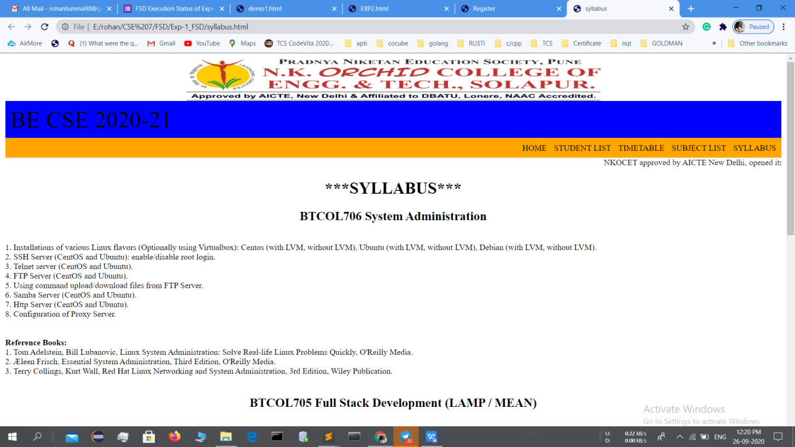

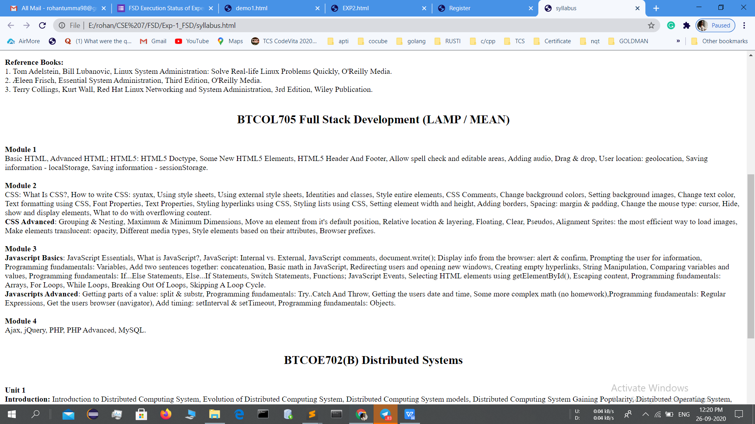

CODE:

<html>

<head>

<title>College Timetable</title>

<style>

table, th, td {

border : 1px solid black;

border-collapse: collapse;

}

th, td {

padding : 5px;

}

p{

}

.head{

background-color:yellow;

color:black;

padding:10px;

font-size:45px;

}

body{

margin:10px;

}

.nav{

background-color:orange;

padding:10px;

text-align:right;

}

.nav a{

color:black;

margin-left:10px;

text-decoration:none;

}

.nav a:hover{

background-color:black;

color:wheat;

}

.foot{

background-color:black;

color:white;

padding:10px;

text-align:center;

}

.mid{

text-align:center;

height:400px;

}

#banner {

padding: 1px;

width: 800px;

height: 80px;

}

#bg

{

height:500px;

width:1080px;

}

</style>

</head>

<body>

<div>

<div>

<center><img id="banner" src="pp.png"></center>

</div>

<div class="head">

BE CSE 2020-21

</div>

<div class="nav">

<a href="index.htm">HOME</a>

<a href="studentlist.html">STUDENT LIST</a>

<a href="timetable2.html">TIMETABLE</a>

<a href="subjectlist.html">SUBJECT LIST</a>

<a href="syllabus.html">SYLLABUS</a>

</div>

<p2><marquee> NKOCET approved by AICTE New Delhi, opened its gate for technology Education from 2008-09.It is recognized by Gov. Of Maharashtra & affiliated to Dr. Babasaheb Ambedkar Technological University, Lonere (DBATU).</marquee></p2>

</div>

<p>

<center><h1>Time Table BE A & B</h1>

<h3>AY: 2020-21 </h3></center>

</p>

<table style="width:60%" align="center">

<tr>

<b>

<th style="width:80px" align="center" >Time/Day</th>

<th style="width:80px" align="center">Mon</th>

<th style="width:80px"align="center">Tue</th>

<th style="width:80px"align="center">Wed</th>

<th style="width:80px"align="center">Thur</th>

<th style="width:80px"align="center">Fri</th>

<th style="width:80px"align="center">Sat</th>

</b>

</tr>

<tr>

<td align="center">10:15 - 11:15</td>

<td align="center">SE</td>

<td align="center">FSD</td>

<td align="center">DS</td>

<td align="center">Elect-X IS</td>

<td align="center">SA</td>

<td align="center">Elect-IX AOS</td>

</tr>

<tr>

<td align="center">11:30 - 12:30</td>

<td align="center">SA</td>

<td align="center">Elect-X IS</td>

<td align="center">SE</td>

<td align="center">FSD</td>

<td align="center">Elect-IX AOS</td>

<td align="center">DS</td>

</tr>

<tr>

<td align="center">12:40 - 1:40</td>

<td align="center"></td>

<td align="center">DS</td>

<td align="center"></td>

<td align="center"></td>

<td align="center">Elect-X IS</td>

<td align="center">SE</td>

</tr>

<tr>

<td align="center">2:30 - 4:30 (Practical)</td>

<td align="center">FSD</td>

<td align="center"></td>

<td align="center"></td>

<td align="center">SA</td>

<td align="center"></td>

<td align="center"></td>

</tr>

</table>

<br>

<table style="width:60%" align="center">

<tr>

<b>

<th rowspan="2" width="50" align="center">Subject</th>

<th rowspan="2" width="50" align="center">Staff Name</th>

<th colspan="8" align="center">Practicals</th>

</b>

</tr>

<tr>

<td>SA1</td>

<td>SA2</td>

<td>SA3</td>

<td>SA4</td>

<td>SB1</td>

<td>SB2</td>

<td>SB3</td>

<td>SB4</td>

</tr>

<tr>

<td align="center">Software Engineering</td>

<td align="center">Prof.P.S.Kankal</td>

<td align="center">-</td>

<td align="center">-</td>

<td align="center">-</td>

<td align="center">-</td>

<td align="center">-</td>

<td align="center">-</td>

<td align="center">-</td>

<td align="center">-</td>

</tr>

<tr>

<td align="center">Distributed System</td>

<td align="center">Prof.M.B.Patil</td>

<td align="center">-</td>

<td align="center">-</td>

<td align="center">-</td>

<td align="center">-</td>

<td align="center">-</td>

<td align="center">-</td>

<td align="center">-</td>

<td align="center">-</td>

</tr>

<tr>

<td align="center">Elect-IX Advanced Operating System</td>

<td align="center">Prof.R.D.Uttarkar</td>

<td align="center">-</td>

<td align="center">-</td>

<td align="center">-</td>

<td align="center">-</td>

<td align="center">-</td>

<td align="center">-</td>

<td align="center">-</td>

<td align="center">-</td>

</tr>

<tr>

<td align="center">Elect-X Information Security</td>

<td align="center">Prof.S.A.Yemul</td>

<td align="center">-</td>

<td align="center">-</td>

<td align="center">-</td>

<td align="center">-</td>

<td align="center">-</td>

<td align="center">-</td>

<td align="center">-</td>

<td align="center">-</td>

</tr>

<tr>

<td rowspan="3" width="50" align="center">Full Stack Development</td>

<td align="center">Prof.S.A.hiremath</td>

<td align="center">RUS</td>

<td align="center">RUS</td>

<td align="center">RUS</td>

<td align="center">RUS</td>

<td align="center"></td>

<td align="center"></td>

<td align="center"></td>

<td align="center"></td>

</tr>

<tr>

<td align="center">Prof.S.A.Hiremath</td>

<td align="center"></td>

<td align="center"></td>

<td align="center"></td>

<td align="center"></td>

<td align="center">SAH</td>

<td align="center">SAH</td>

<td align="center">SAH</td>

<td align="center"></td>

</tr>

<tr>

<td align="center">Prof.S.A.Yemul</td>

<td align="center"></td>

<td align="center"></td>

<td align="center"></td>

<td align="center"></td>

<td align="center"></td>

<td align="center"></td>

<td align="center"></td>

<td align="center">SAY</td>

</tr>

<tr>

<td rowspan="3" width="50" align="center">System Administration</td>

<td align="center">Prof.A.R.Chinchwade</td>

<td align="center">ARC</td>

<td align="center">ARC</td>

<td align="center">ARC</td>

<td align="center">ARC</td>

<td align="center">ARC</td>

<td align="center">ARC</td>

<td align="center"></td>

<td align="center"></td>

</tr>

<tr>

<td align="center">Prof.M.S.Otari</td>

<td align="center"></td>

<td align="center"></td>

<td align="center"></td>

<td align="center"></td>

<td align="center"></td>

<td align="center"></td>

<td align="center">MSO</td>

<td align="center">MSO</td>

</tr>

</table>

<br>

<p style="width:60%" align="center">

<center><h4 >BE A Class Coordinator :- <b> Prof.S.A.Yemul</b>

<br>BE B Class Coordinator :- <b> Prof.A.R.Chinchwade </b> </h4></center>

</body>

</html>

